Steve Javins

IT 201

**Project 2 Description and Storyboard**

    Project 2's overall concept was to provide basic company information in an easy to use and fun/animated flash interface and presentation. Originally designated colors, text styles, etc. were followed closely in the majority of the design. The presentation incorporates the advertising banner made previously and simple logo. Each slide utilizes either motion or shape tweens as well as timeline effects to introduce some key points about Data Lock inc. Graphics were both created and imported and used along with text to create various effects.

    In the movie, many of the same techniques were applied to graphics and text. In addition to such, an MP3 file was embedded and edited to enhance the impact of the material on the user. A fade out was used on the sound effect which begins in frame one of the movie and the same file was shortened down to a fraction of a second and applied to each button on the "down" action. With this, the snippet of sound will play each time the user presses a button which is also known as an event sound. This movie particular movie also separates each section into a different layer in order to create a staggering effect which allows the playability of the document.

**Storyboard**

Review old designs



Decide content/organization

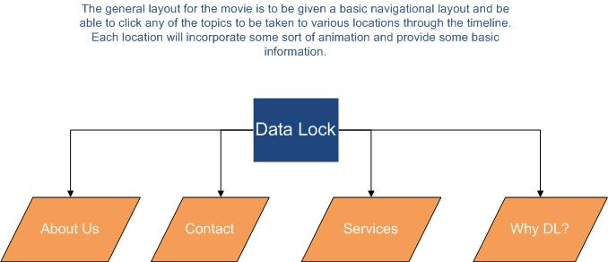

Design layout

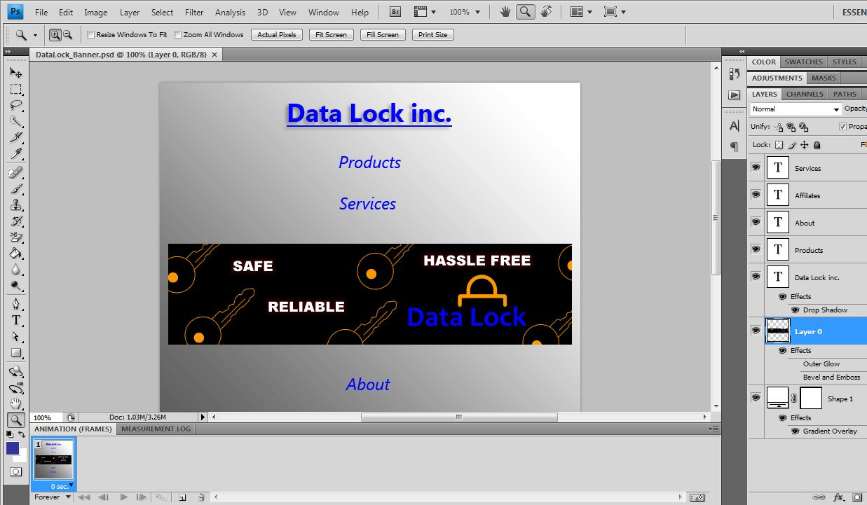

Construct

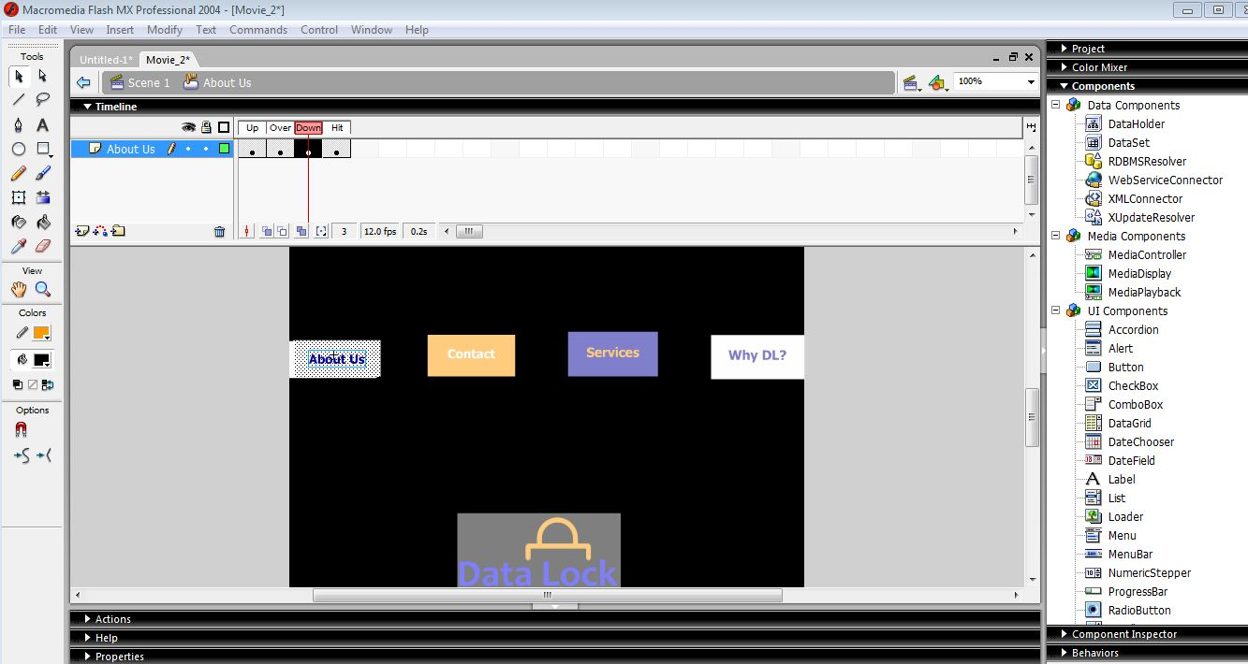

Review/Critique

